**1. Design Overview**

- This document describes the technical and user interface design of MSSC System. It includes the architectural design, the detailed design of common functions and business functions and the design of database model.

- The architectural design describes the overall architecture of the system and the architecture of each main component and subsystem.

- The detailed design describes static and dynamic structure for each component and functions. It includes class diagrams, class explanations and sequence diagrams for each use cases.

- The database design describes the relationships between entities and details of each entity. - Document overview:

* + Section 2: gives an overall description of the system architecture design.
  + Section 3: gives component diagrams that describe the connection and integration of the system.
  + Section 4: gives the detail design description which includes class diagram, class explanation, and sequence diagram to details the application functions.
  + Section 5: describe screens design.
  + Section 6: describe a fully attributed ERD.
  + Section 7: describe algorithms.

**Mobile architecture design**

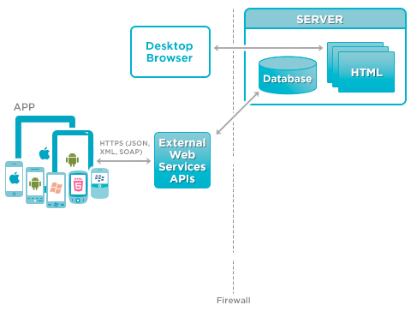

### Web Application architecture description

In Web Application, the system is developed under J2EE MVC architecture style. We choose this architecture for Web application because of in scope of 4-member team, MVC architecture make it easier to split the big project into small modules and make it easier to assign each module for members in our team.

This project follows MVC architecture with following components:

* **Servlet (Controller)** is the parts of the application that acts like event handler to handles user interaction. Typically, controller read data from a request and calls appropriate Business’s method then selects view to return to user.
* **JSP/HTML (View)** is the parts of the application that handles the display of the data. The selection of View is under control of Controller.
* **Business** is the parts of the application that do business processing to solve domain problems.
* **Model** is the parts of the application that acts like a data transfer object between the system and database.
* **Web Service** is the parts of the application that acts like event handler for web and mobile communication via REST method.